- MASTER THE SKILL OF SIMPLICITY IN TENNIS COACHING
https://www.youtube.com/watch?v=prXpB_Foy2U&list=WL&index=9

- Roger Federer questioned/talks about his forehand grip?

https://youtu.be/I18w2xGkoMo?si=lQ2EPx-KVlKJJHx8

- Serena Williams talks about her forehand grip? (Lewis Hamilton Instagram post. Click next)

https://www.instagram.com/p/CkJjGkxS8bd/?img_index=1&igsh=MTV4aTZweDJ5ajhjMw==

- HOW DO I GET BEGINNERS STARTED IN TENNIS, AND HOW DO I INTRODUCE "CORRECT" TECHNIQUE? (by Mark Tennant - one of best Coaching education Tutor’s in the UK)
https://youtu.be/XdBCDyYP468?si=pVc9u-7ZzNgKAk0b

- Sania Mirza giving her perspective of the sport!
https://www.instagram.com/reel/DOQsbJ0iJO6/?utm_source=ig_web_copy_link&igsh=MzRlODBiNWFlZA==

- How parents slow their child’s tennis development without even realizing it!
https://www.instagram.com/p/DR0br4PDQsj/?utm_source=ig_web_copy_link&igsh=MzRlODBiNWFlZA==

- Rafa Nadal perspective on technique?
https://www.instagram.com/p/DQ-coOIjsbT/?utm_source=ig_web_copy_link

- What am I doing?
https://www.instagram.com/reel/DRerH7RDH_Y/?utm_source=ig_web_copy_link&igsh=MzRlODBiNWFlZA==

- What (actually) makes a champion?
https://www.instagram.com/p/DRNk3hxksEQ/?utm_source=ig_web_copy_link&igsh=MzRlODBiNWFlZA==

- Why do you play your best against better players?
https://www.instagram.com/p/DRaM9h0ibWw/?utm_source=ig_web_copy_link&igsh=MzRlODBiNWFlZA==

- Taylor Fritz Insight on speed! (note: One of the best server’s in the game)
https://www.instagram.com/reel/DQ47G6fDAVE/?utm_source=ig_web_copy_link

- The serves of the eight best players in the world and Alexandrova (WTA No 10) in slow motion at the WTA Finals Riyadh.
https://www.instagram.com/p/DQ6vv3PiLWt/?utm_source=ig_web_copy_link&igsh=MzRlODBiNWFlZA==

- Marta Kostyuk makes an honest confession about her matches with Aryna Sabalenka and Iga Swiatek!
https://www.instagram.com/p/DQCGhxAEVQ3/?utm_source=ig_web_copy_link&igsh=MzRlODBiNWFlZA==

- Roger Federer is known for his elite tennis play and mindset. What are you afraid of when competing? (note: what about technique?)
https://www.instagram.com/reel/DOt-_6BkRel/?utm_source=ig_web_copy_link&igsh=MzRlODBiNWFlZA==

- Pro athlete take on the definition of success? (just brilliant!!)
https://www.instagram.com/reel/DPXPJdHE2Ob/?utm_source=ig_web_copy_link&igsh=MzRlODBiNWFlZA==

- Footwork example!
https://www.instagram.com/reel/DPTYgbkCF6G/?utm_source=ig_web_copy_link&igsh=MzRlODBiNWFlZA==

- Hand signals in doubles
https://www.instagram.com/reel/DOf7irDDBkx/?utm_source=ig_web_copy_link&igsh=MzRlODBiNWFlZA==

- 2024 Commencement Address by Roger Federer at Dartmouth!
https://www.youtube.com/watch?v=pqWUuYTcG-o&list=PLPG4xJF2wnqSspmj2fNwAgYETXZgwaMq9

- The Players Ask Novak ALL The Questions... Don't Miss These Answers
https://www.youtube.com/watch?v=nb7Xh-FBIzs&list=PLPG4xJF2wnqSspmj2fNwAgYETXZgwaMq9&index=3

- WTA tour Forehands (what to learn from it?)
https://www.youtube.com/watch?v=ULIxMsGg-c4&list=PLPG4xJF2wnqSspmj2fNwAgYETXZgwaMq9&index=6

- Tennis Rules for Beginner [1]
https://www.youtube.com/watch?v=TuM5Uh4ii3Q&list=PLPG4xJF2wnqSspmj2fNwAgYETXZgwaMq9&index=41

- The Rules of Tennis EXPLAINED (scoring, terms and more) [2]
https://www.youtube.com/watch?v=jrhM3k84YJU

- How to Keep Score in Tennis (Simple Guide for Beginners) [3]
https://www.youtube.com/watch?v=QXYO-clEZNI

- How to Play Tennis for Beginners | Rules, Scoring, and Tips [4]
https://www.youtube.com/watch?v=ogYGv0g3VFA

- STOP this Tennis Mistake!
https://www.youtube.com/watch?v=Dcq3Lhhu5I0&list=PLPG4xJF2wnqSspmj2fNwAgYETXZgwaMq9&index=56

- Stop Standing HERE In Tennis!
https://www.youtube.com/watch?v=_l-RReCl6Ho&list=PLPG4xJF2wnqSspmj2fNwAgYETXZgwaMq9&index=57

- DON’T Control Your Nerves!
https://www.youtube.com/watch?v=8mjMsU-vvEQ&list=PLPG4xJF2wnqSspmj2fNwAgYETXZgwaMq9&index=58

- “Why Most Private Tennis Lessons are a Waste of Money and Time”
https://www.youtube.com/watch?v=wN90jf60mW8

- How Long Does It Take To Learn Tennis?
https://www.youtube.com/watch?v=so3gA03Qx9w

- Tennis stats/facts/curiosities:

- THE TOP 100! THE 100 PLAYERS WITH MOST WINS IN THE OPEN ERA!
https://www.instagram.com/p/DRmvnzmESSM/?utm_source=ig_web_copy_link&igsh=MzRlODBiNWFlZA==

- GRAND SLAMS CHAMPIONS IN THE OPEN ERA!
https://www.instagram.com/p/DRXJZjEke5C/?utm_source=ig_web_copy_link&igsh=MzRlODBiNWFlZA==

- Jannik Sinner 2025 stats! (record!)
https://www.instagram.com/p/DRQFMgZDMk3/?utm_source=ig_web_copy_link&igsh=MzRlODBiNWFlZA==

- CRAZY STAT!!! Carlos Alcaraz and Jannik Sinner have won exactly the same points through their 16 ATP Tour matches.
https://www.instagram.com/p/DRIysLKjxaB/?utm_source=ig_web_copy_link

- Tennis Players Ratings
https://www.youtube.com/watch?v=HMHrmi1JGzI&list=PLPG4xJF2wnqSspmj2fNwAgYETXZgwaMq9&index=4

- ASTONISHING Drama In Tiafoe vs Raonic Over Unusual Rule
https://www.youtube.com/watch?v=kbXWwxi9Wk4&list=WL&index=21

- Tennis Players When They Were Kids!
https://www.youtube.com/watch?v=qhy478W64mA&list=WL&index=27

- Roger Federer doesn't realise he's won match
https://www.youtube.com/watch?v=njvK_EII2GI&list=PLPG4xJF2wnqSspmj2fNwAgYETXZgwaMq9&index=45

- Tennis isn’t just “good exercise”, it’s one of a clearest standouts in a longevity battle when researchers compare sports head-to-head.⁠
https://www.instagram.com/p/DSkRB4oEhIm/?utm_source=ig_web_copy_link

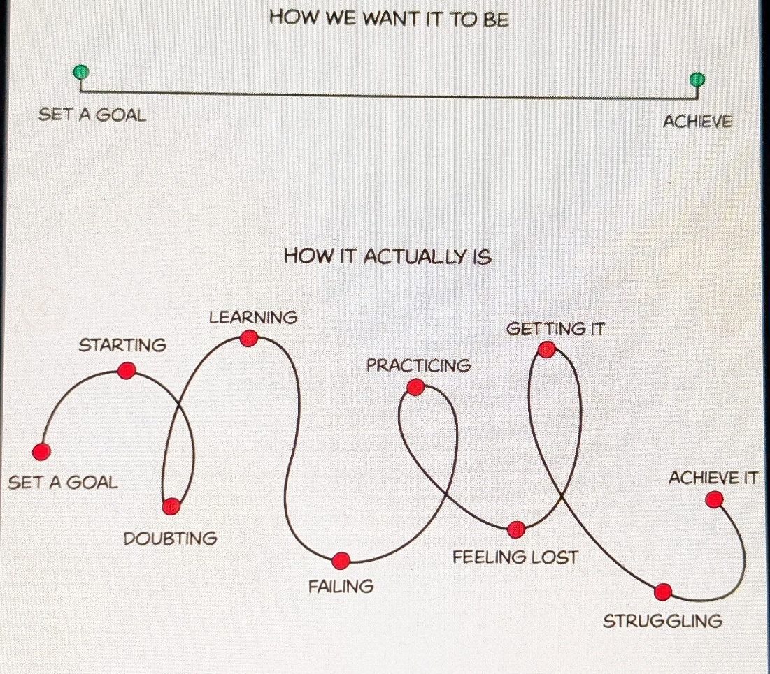

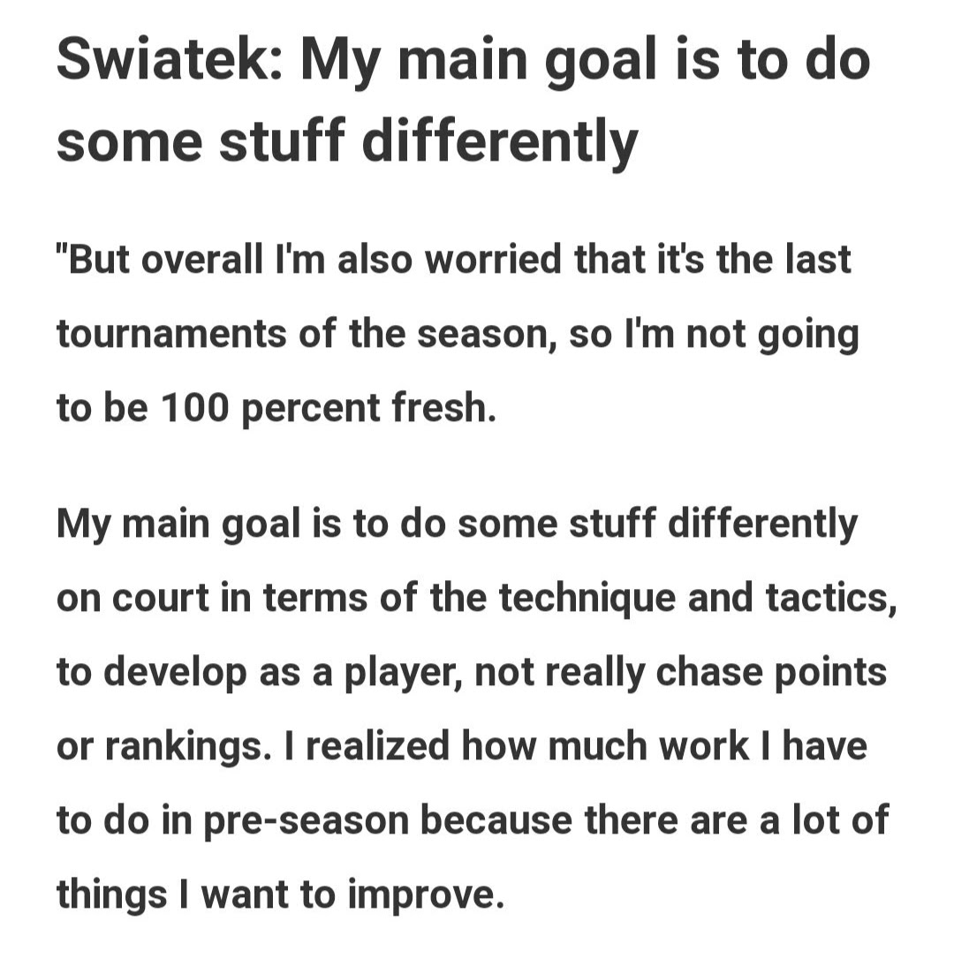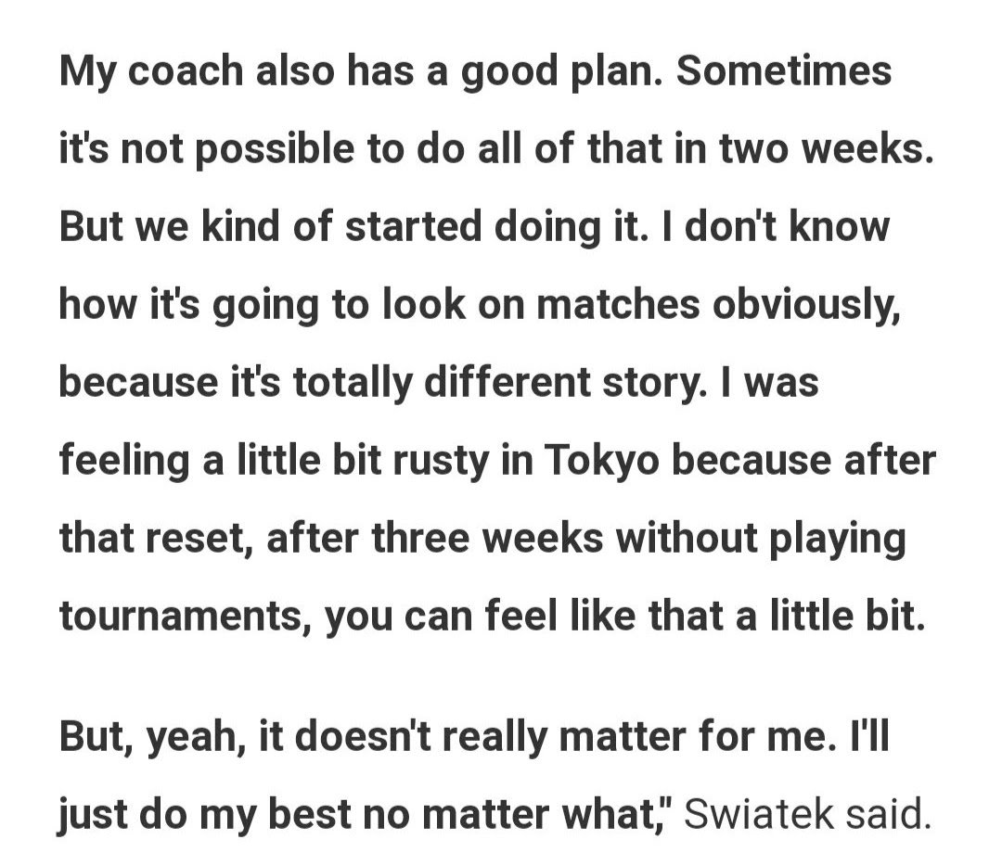

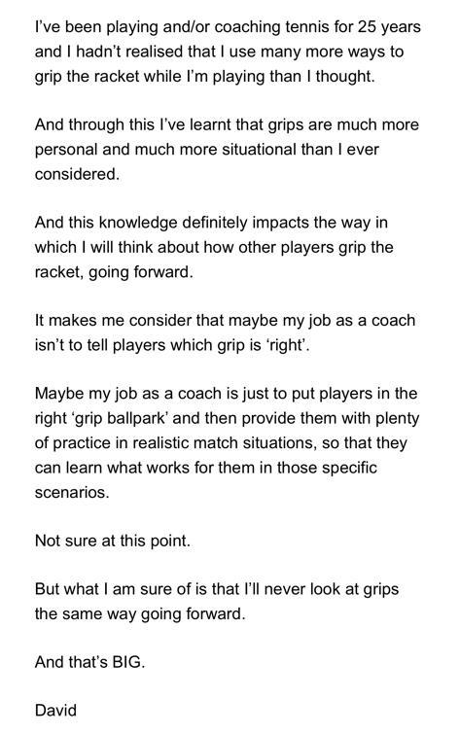

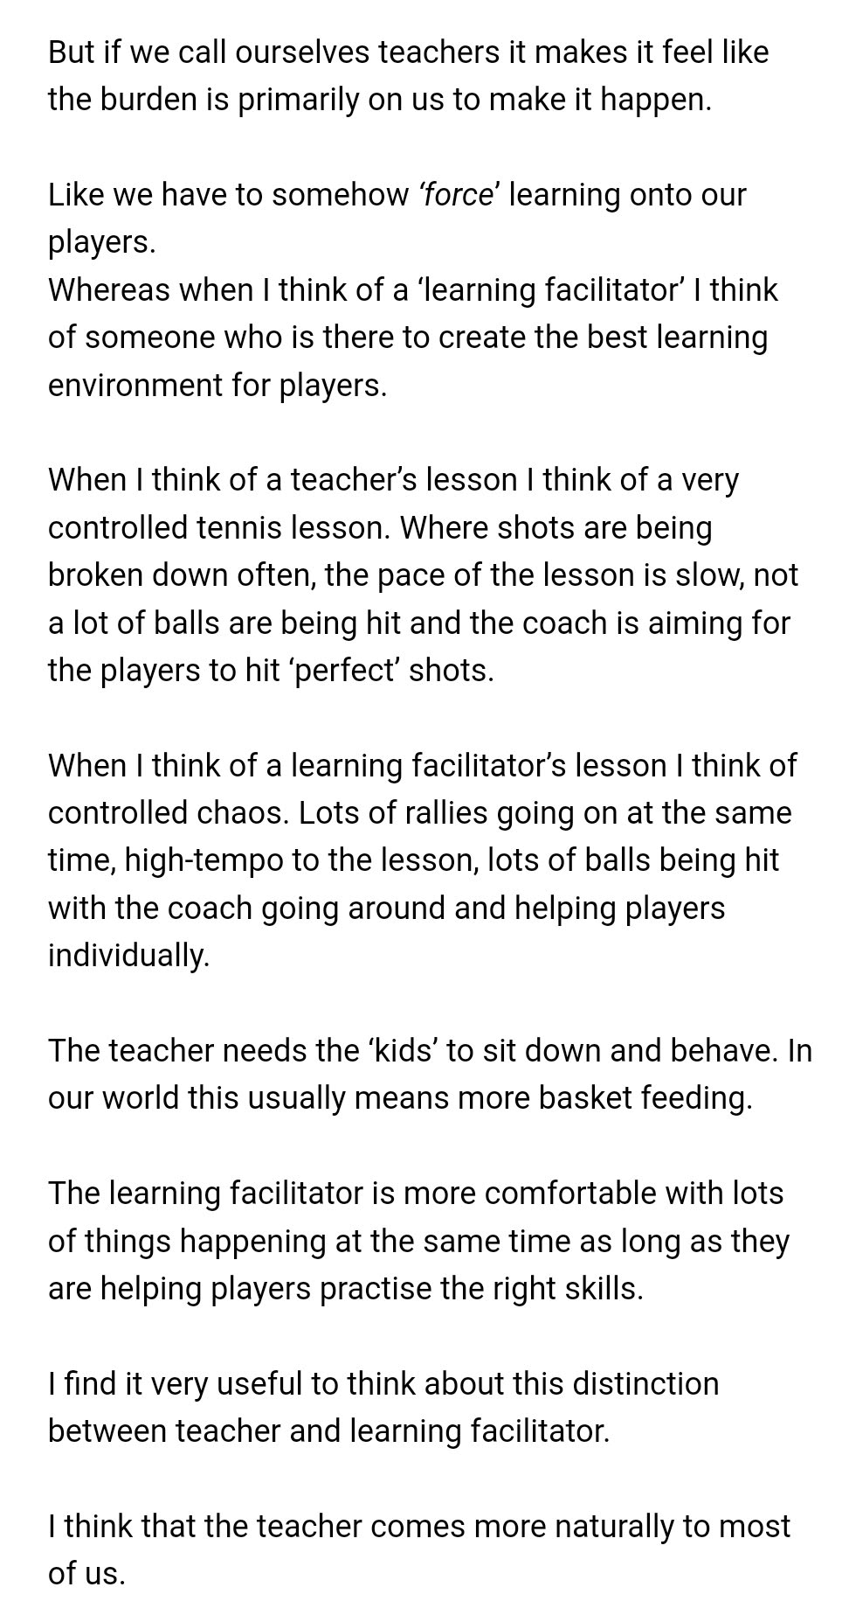

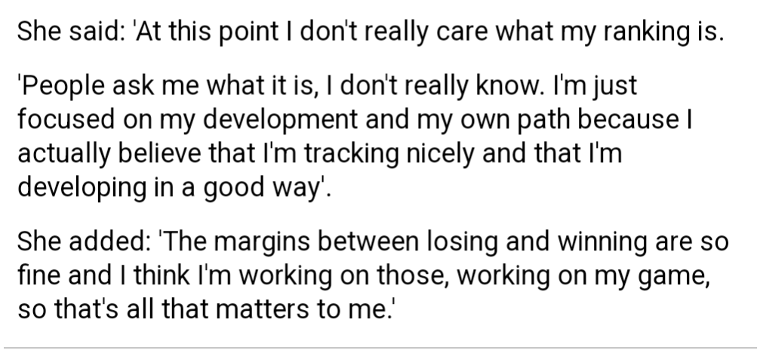

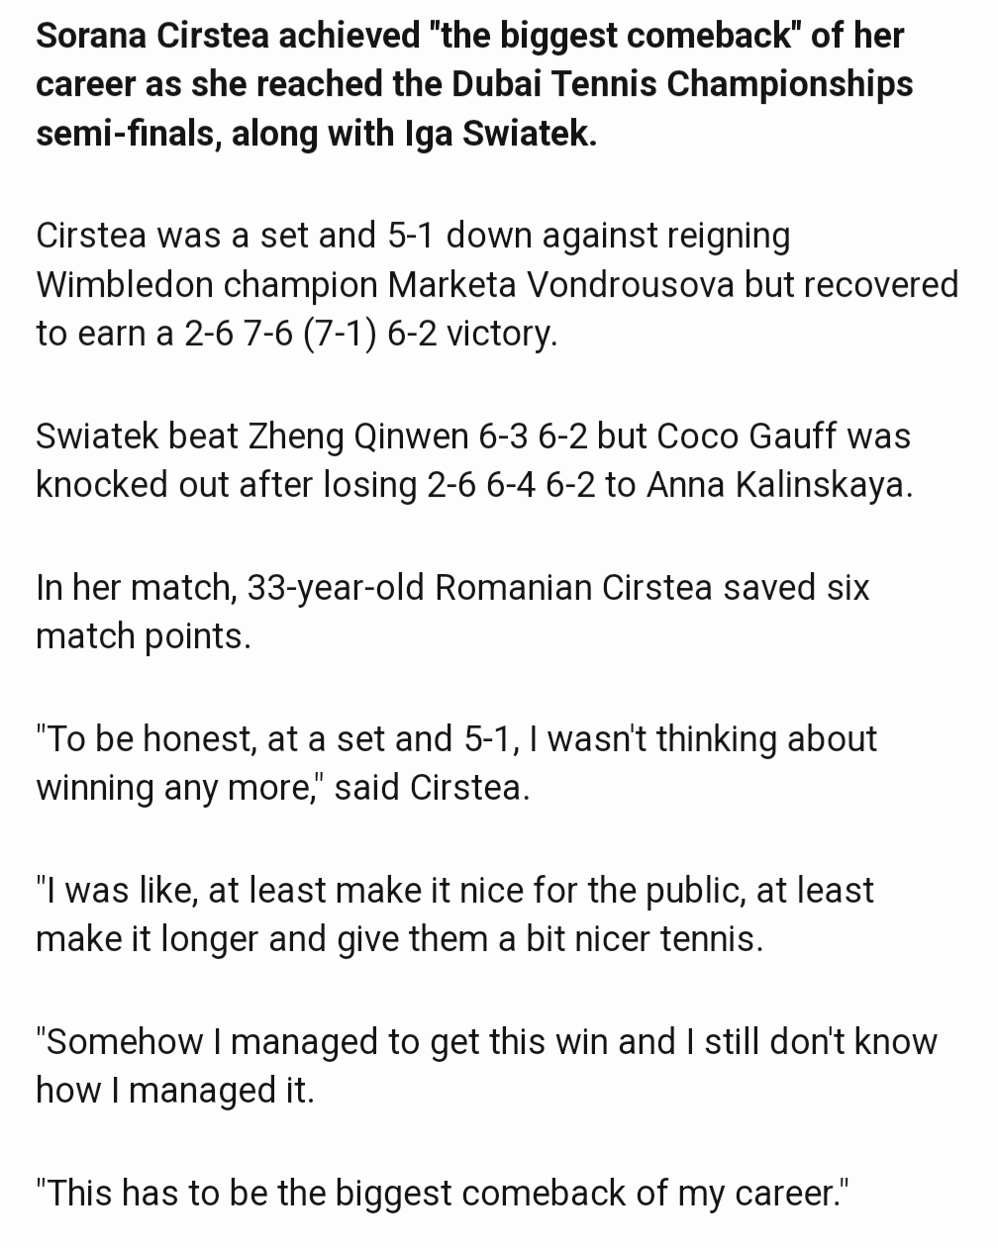

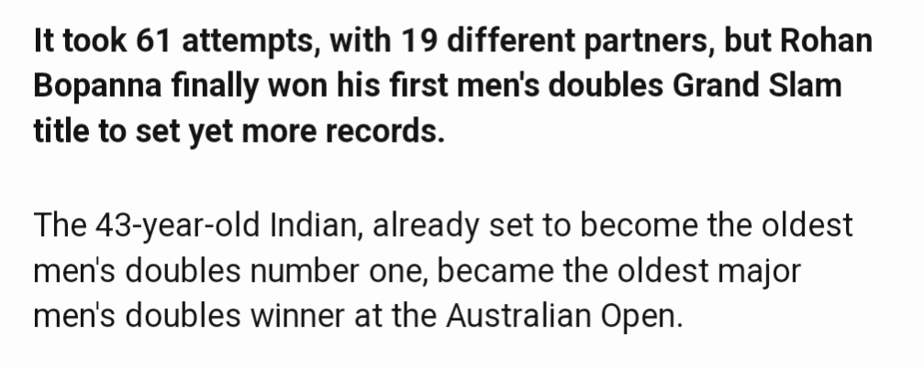

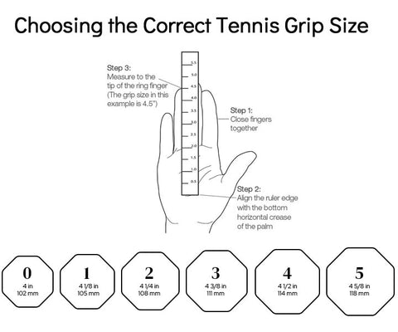

- Other topics:

- Most people don’t want to hurt you — they’re simply speaking from their own wounds, fears, or stories.
https://www.instagram.com/p/DRhKIxfAU-Q/?utm_source=ig_web_copy_link

- Smartphones ‘damage family life’ and are a ‘constant distraction’!
https://www.instagram.com/reel/DPlySHZDKnw/?utm_source=ig_web_copy_link&igsh=MzRlODBiNWFlZA==

- Big tech companies are selling schools the “digital classroom” as the future!
https://www.instagram.com/reel/DQYmSqIj7Dc/?utm_source=ig_web_copy_link

- On the reality of modern TV and dumbing down!
https://www.instagram.com/reel/DQJIBowiCv6/?utm_source=ig_web_copy_link&igsh=MzRlODBiNWFlZA==

- Doing nothing saves your child’s brain!
https://www.instagram.com/p/DQuf8ABAm0D/?utm_source=ig_web_copy_link&igsh=MzRlODBiNWFlZA==

- Phones effect…!?
https://www.instagram.com/p/DPbhufviLxG/?utm_source=ig_web_copy_link&igsh=MzRlODBiNWFlZA==

- Brilliant educated/intelligent English young man!!
https://www.instagram.com/reel/DOGAcosDHNt/?utm_source=ig_web_copy_link&igsh=MzRlODBiNWFlZA==

- AI failure explained!
https://www.instagram.com/reel/DPGEpT0Dj8F/?utm_source=ig_web_copy_link&igsh=MzRlODBiNWFlZA==

- How easy is to manipulate us!!
https://www.instagram.com/p/DOc1Iw_jFvW/?utm_source=ig_web_copy_link&igsh=MzRlODBiNWFlZA==

- Why the majority is always wrong | Paul Rulkens
https://www.youtube.com/watch?v=VNGFep6rncY&list=WL&index=53

- Genius Mom Gives Her Kids Budget For Snacks
https://www.youtube.com/watch?v=qo4yTGwdDnI&list=WL&index=61

- We're All Guilty Of This
https://www.youtube.com/watch?v=mHoAV3FMQxI&list=WL&index=62

- Matthew McConaughey | 5 Minutes for the NEXT 50 Years of Your LIFE
https://www.youtube.com/watch?v=OKJImnk-gzQ&list=WL&index=81

- Why you don't need electrolytes for everyday exercise
https://www.bbc.co.uk/news/articles/cev1v8wr8m7o

